S.K. LOHIT DEVESHWAR

192211054

CLOUD COMPUTING AND BIG DATA ANALYTICS FOR GENERIC APPLICATIONS

EXP 1 **Flight Reservation System**

**step1:** Go to zoho.com.

**step 2:** Log into the zoho.com.

**step 3:** Select one application step.

**step4:** Enter application name as product selling.

**step 5:** Created new application as product selling.

**step 6:** Select one form

**step 7:** The software has been created.

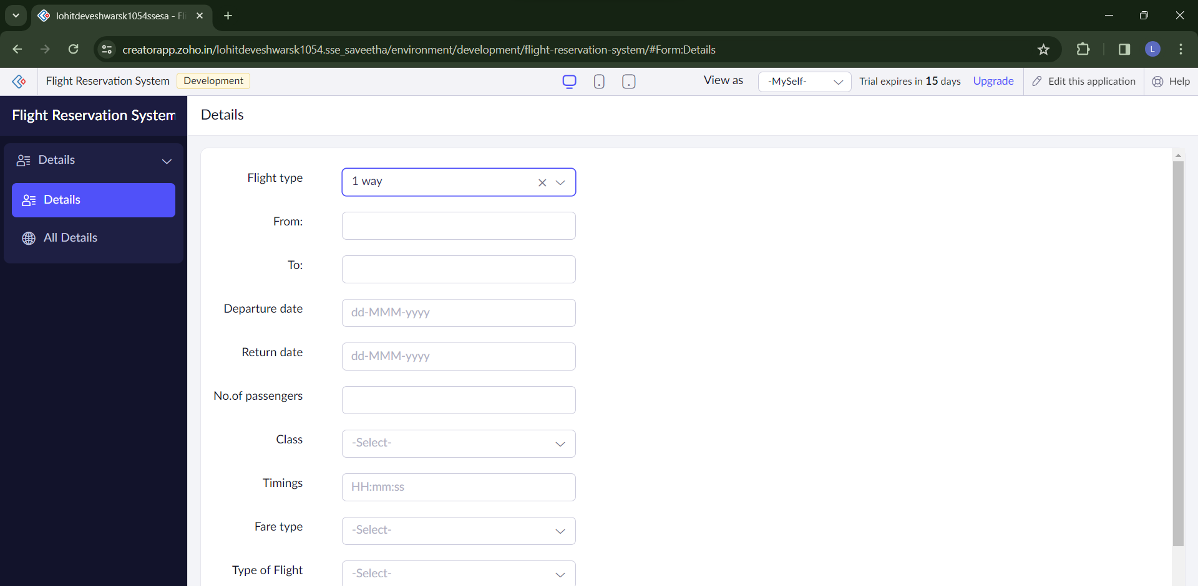

EXP2 **Property sales and rent**

**step1:** Go to zoho.com.

**step 2:** Log into the zoho.com.

**step 3:** Select one application step.

**step4:** Enter application name as product selling.

**step 5:** Created new application as product selling.

**step 6:** Select one form

**step 7:** The software has been created.

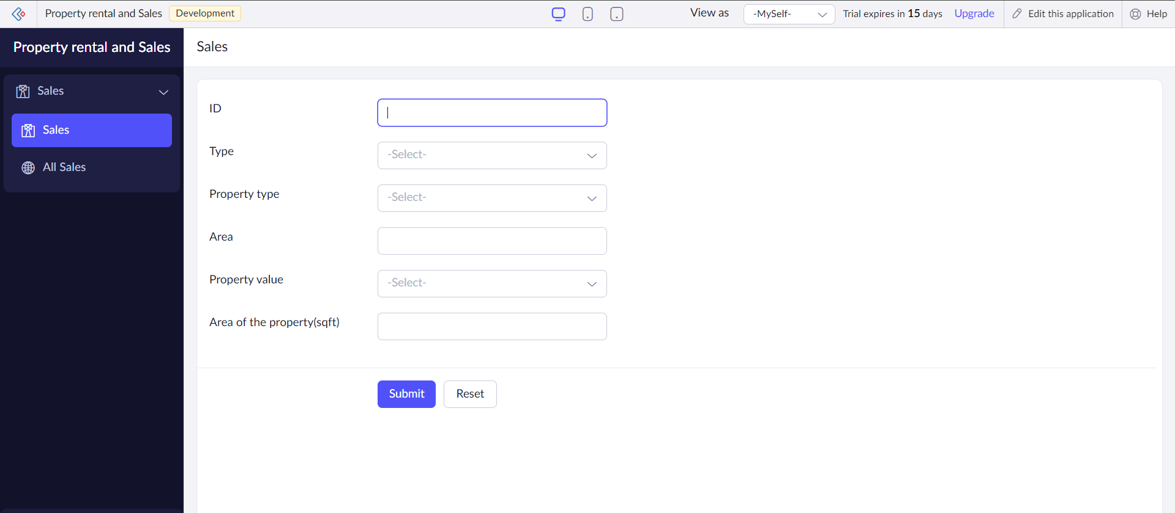

EXP3 **Cab Reservation system**

**step1:** Go to zoho.com.

**step 2:** Log into the zoho.com.

**step 3:** Select one application step.

**step4:** Enter application name as product selling.

**step 5:** Created new application as product selling.

**step 6:** Select one form

**step 7:** The software has been created.

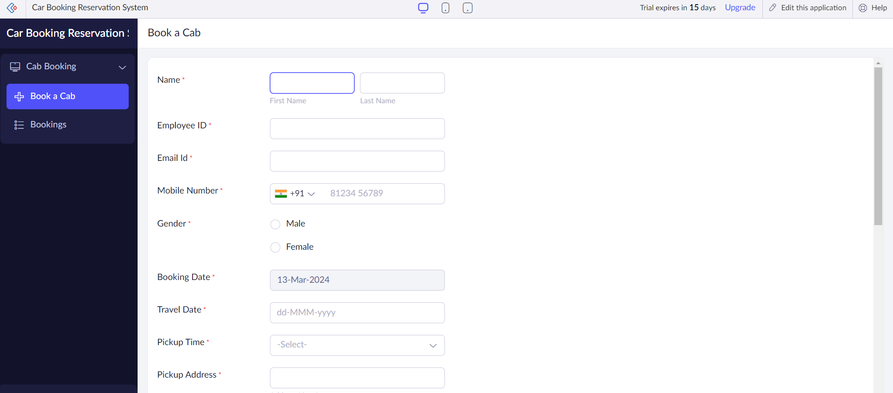

EXP4 **Simats Library**

**step1:** Go to zoho.com.

**step 2:** Log into the zoho.com.

**step 3:** Select one application step.

**step4:** Enter application name as product selling.

**step 5:** Created new application as product selling.

**step 6:** Select one form

**step 7:** The software has been created.

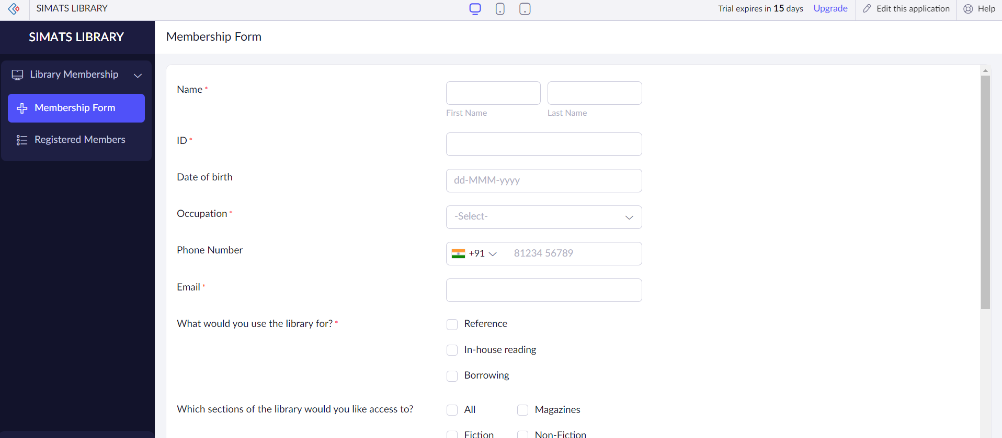

Exp 5 Marksheet Processing

* Create a New Application
* Click on “Create New Application.”
* Define the necessary fields as described above.
* Design Forms and Views: Create forms for entering student details, subject-wise marks, and overall performance.
* Set up views to display student records, subject-wise marks, and performance summaries.

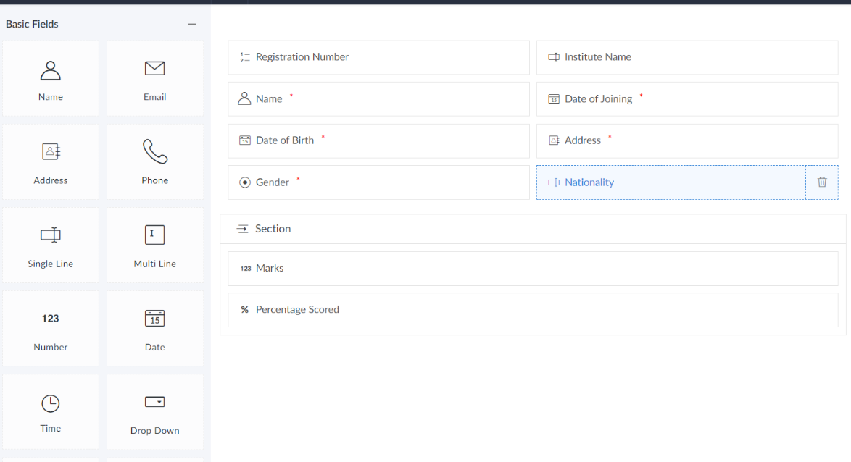

Exp 6 **PRODUCT SELLING**

* Go to zoho.com.
* Log into the zoho.com.
* Select one application step.
* Enter application name as product selling.
* Created new application as product selling.
* Select one form
* The software has been created.

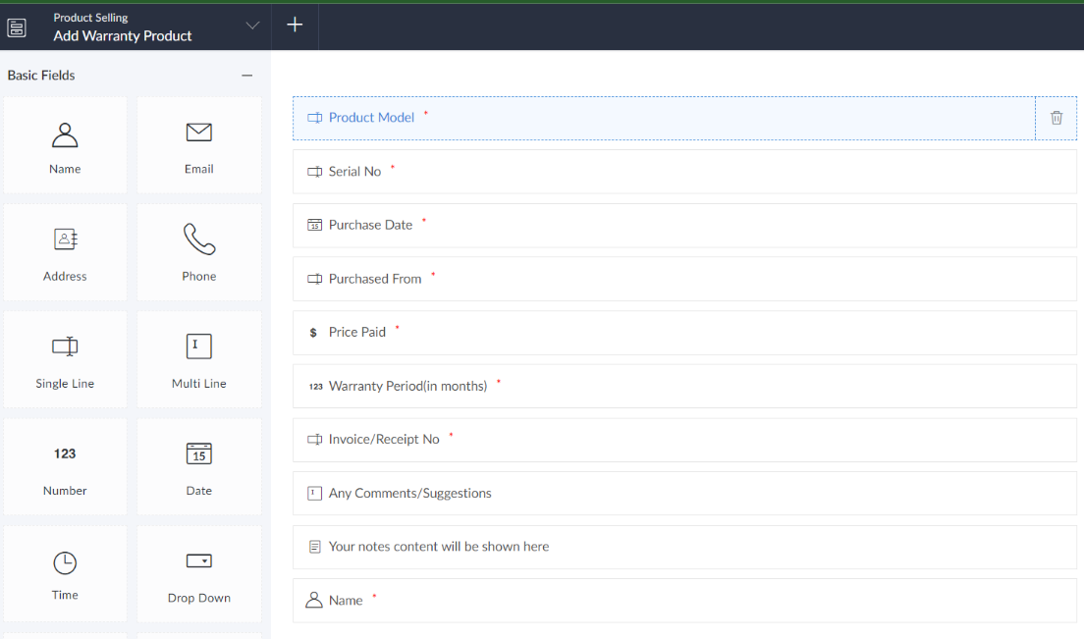

Exp 7 **VM ware for type2 hypervisor with an os**

**STEP 1:**Dowload VMware workstation and installed as type 2 hypervisor.

**STEP2:**Dowload ubuntu or tiny OS as iso image file.

**STEP 3:** In VMware workstation->create new VM.

**STEP 4:** Do the basic configuration settings.

**STEP 5:** Created tiny OS virtual machine.

**STEP 6:** Launch the VM.

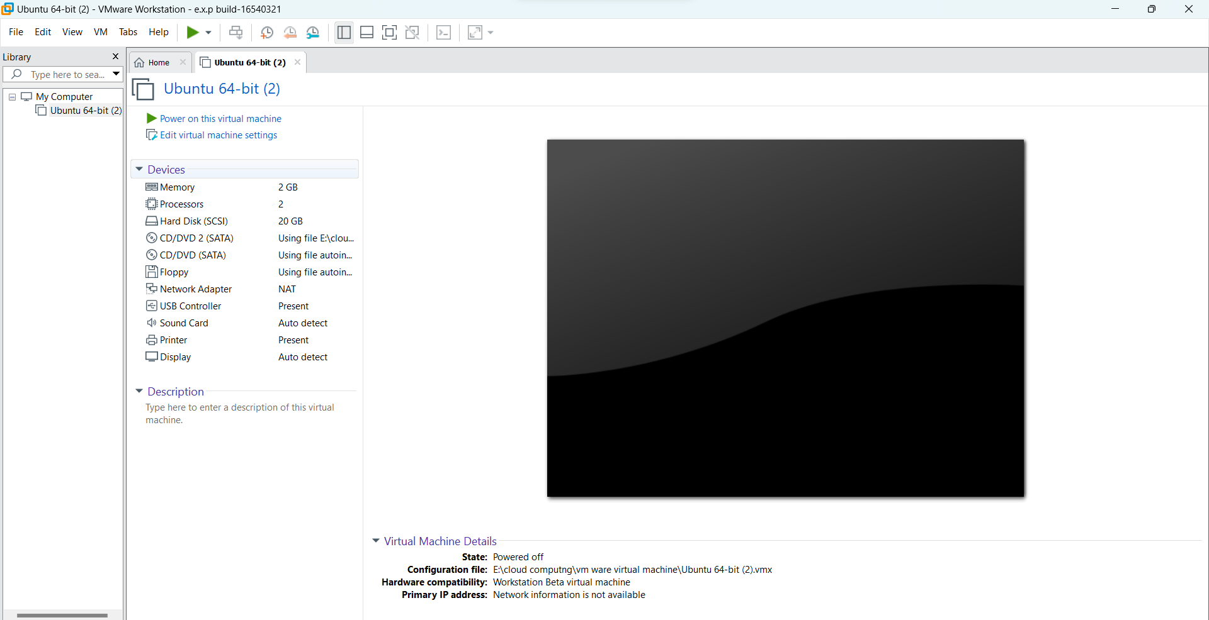

Exp 8 **Create a Virtual Machine with 1 CPU, 2GB RAM and 15GB storage disk**

**STEP 1:**Dowload VMware workstation and installed as type 2 hypervisor.

**STEP2:**Dowload ubuntu or tiny OS as iso image file.

**STEP 3:** In VMware workstation->create new VM.

**STEP 4:** Do the basic configuration settings.

**STEP 5:** Created tiny OS virtual machine.

**STEP 6:** Launch the VM.

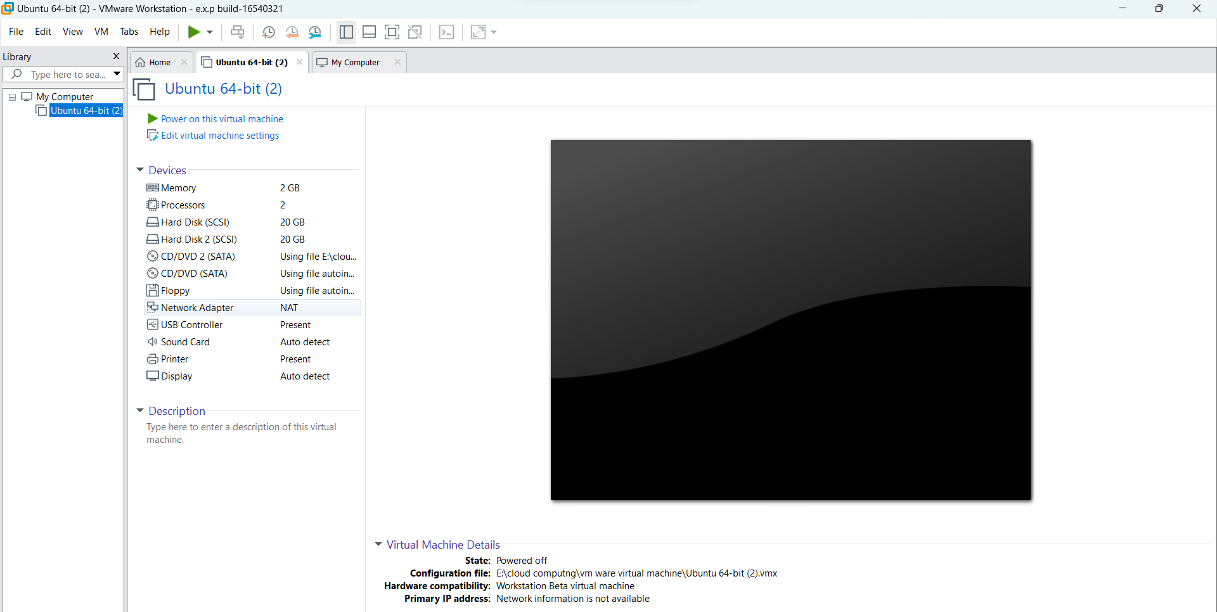

Exp 9

* Goto Vmware Workstation.
* Right Click The Vm And Goto The Settings.
* Add Hardware Wizard And Select Scsi And Click Next.
* Create New Virtual Disk.
* Select The Disk Size As 2.0. And Select Split Virtual Disk Into Multi Files.
* Give Name And Click The Finish.

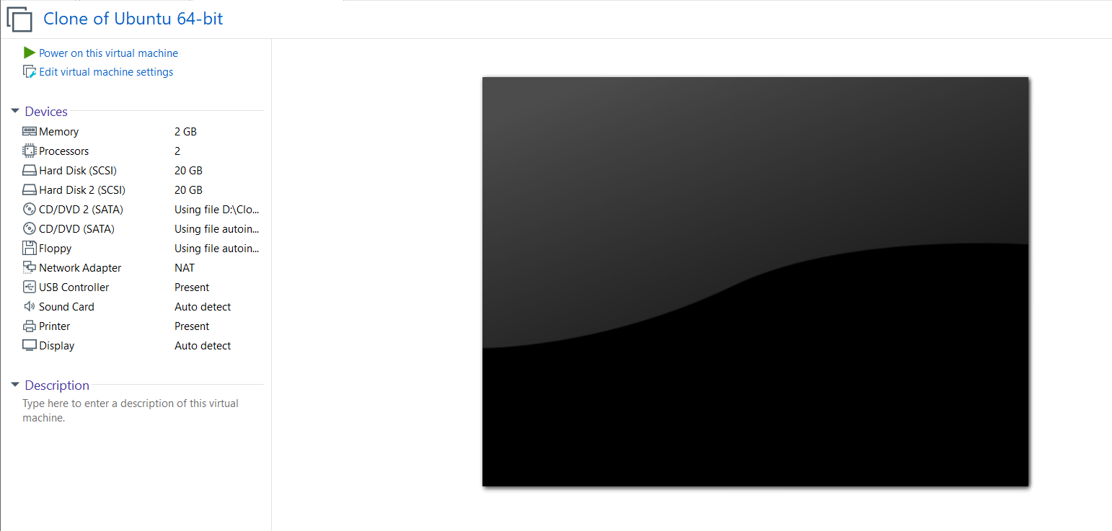

Exp 10 **VIRTUAL MACHINE USING VM WARE**

* Goto Vmware Workstation.
* Create Files On Desktop.
* Click On Vm And Selects Snapshot-> Take Snapshot.
* Snapshot Is Being Done.

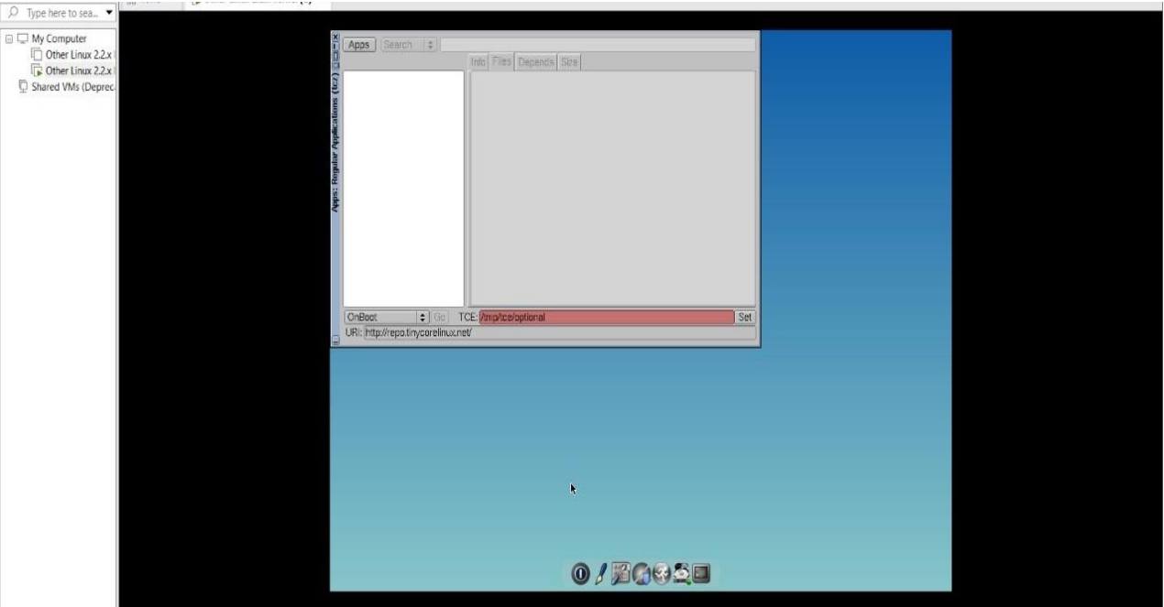

Exp 11 **VM USING VM WARE**

* Goto Vmware Workstation.
* Create Files On Desktop.
* Click On Vm And Selects Snapshot-> Take Snapshot.
* Snapshot Is Being Done.

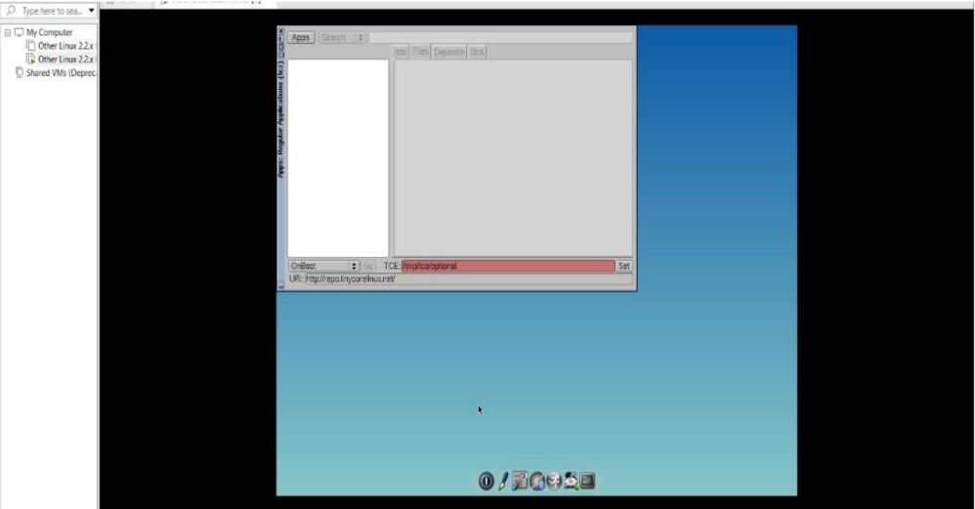

Exp12

* Goto Vmware Workstation.
* Right Click The Vm And Goto The Settings.
* Add Hardware Wizard And Select Scsi And Click Next.
* Create New Virtual Disk.
* Select The Disk Size As 2.0. And Select Split Virtual Disk Into Multi Files.
* Give Name And Click The Finish.



Exp 13 **VIRTUAL MACHINE USING MICROSOFT AZURE**

**STEP1:** CREATE AN ACCOUNT IN MICROSOFT AZURE.

**STEP2:** GOTO RESOURCE GROUP AND CREATE A RESOURCE GROUP.

**STEP3:** GIVE NECESSARY THINGS FOR RESOURCE GROUP.

**STEP4:** CREATE A VIRTUAL NETWORK FOR TO CREATE A VIRTUAL MACHINE .

**STEP5**: NOW CREATE A VIRTUAL MACHINE WITH UR IP ADDRESS AN USERNAME AND PASSWORD FOR YOUR VIRTUAL MACINE.

**STEP6**: AND YOUR VIRTUAL MACHINE IS DEPLOYED.

**STEP7:** NOW CONNECT THE VIRTUAL MACHINE AND DOWNLOAD THE RDP FILE TO OPEN YOUR WINDOWS VIRTUAL MACHINE.

**STEP8:** NOW RESIZE THE VIRTUAL MACHINE SIZE.

**STEP9:** CREATED A NEW WINDOWS VIRTUAL MACHINE

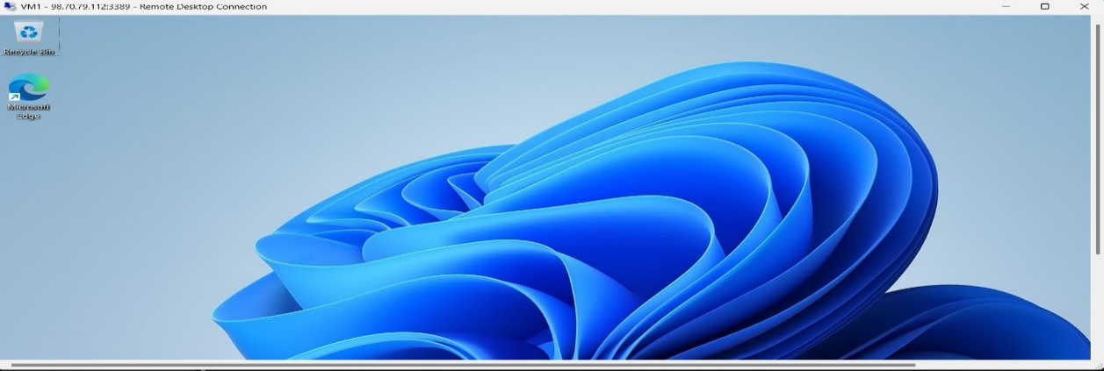

Exp14  **WEB SEREVER USING MICROSOFT AZURE**

**STEP1:** CREATE AN ACCOUNT IN MICROSOFT AZURE.

**STEP2:** GOTO RESOURCE GROUP AND CREATE A RESOURCE GROUP.

**STEP3:** GIVE NECESSARY THINGS FOR RESOURCE GROUP.

**STEP4:** CREATE A VIRTUAL NETWORK FOR TO CREATE A VIRTUAL MACHINE .

**STEP5**: NOW CREATE A VIRTUAL MACHINE WITH UR IP ADDRESS AN USERNAME AND PASSWORD FOR YOUR VIRTUAL MACINE.

**STEP6**: AND YOUR VIRTUAL MACHINE IS DEPLOYED.

**STEP7:** NOW CONNECT THE VIRTUAL MACHINE AND DOWNLOAD THE RDP FILE TO OPEN YOUR WINDOWS VIRTUAL MACHINE.

**STEP8:** NOW RESIZE THE VIRTUAL MACHINE SIZE.

**STEP9:** CREATED A NEW WINDOWS VIRTUAL MACHINE

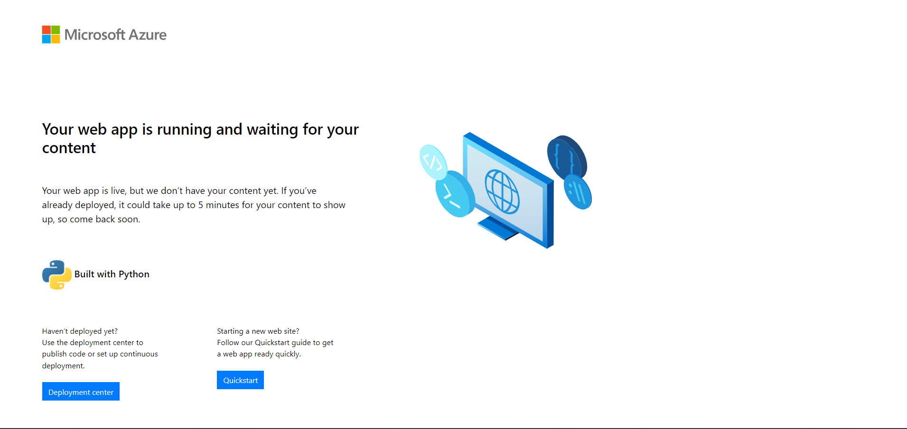

Exp15 **VIRTUAL STORAGE USING AZURE**

**STEP1:** CREATE AN ACCOUNT IN MICROSOFT AZURE.

**STEP2:** GOTO RESOURCE GROUP AND CREATE A RESOURCE GROUP.

**STEP3:** GIVE NECESSARY THINGS FOR RESOURCE GROUP.

**STEP4:** CREATE A VIRTUAL NETWORK FOR TO CREATE A VIRTUAL MACHINE .

**STEP5**: NOW CREATE A VIRTUAL MACHINE WITH UR IP ADDRESS AN USERNAME AND PASSWORD FOR YOUR VIRTUAL MACINE.

**STEP6**: AND YOUR VIRTUAL MACHINE IS DEPLOYED.

**STEP7:** NOW CONNECT THE VIRTUAL MACHINE AND DOWNLOAD THE RDP FILE TO OPEN YOUR WINDOWS VIRTUAL MACHINE.

**STEP8:** NOW RESIZE THE VIRTUAL MACHINE SIZE.

**STEP9:** CREATED A NEW WINDOWS VIRTUAL MACHINE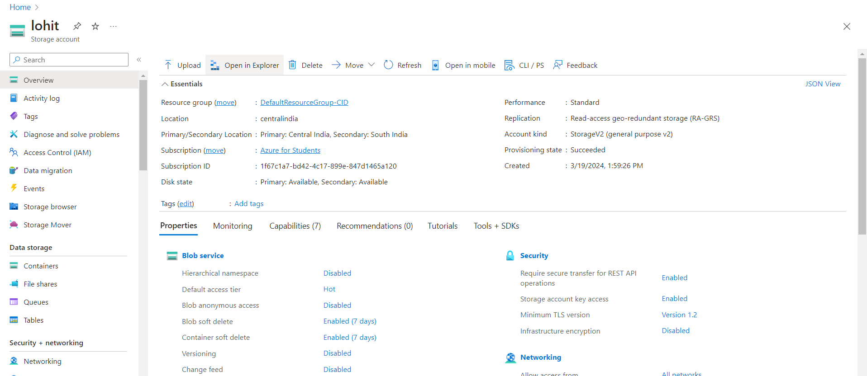

Exp **16 DEMONSTRATE INFRASTRUCTURE AS A SERVICE(IAAS) BY CREATING AVIRTUAL MACHINE USING A PUBLIC CLOUD SERVICE PROVIDER(AZURE/GCP/AWS) CONFIGURE WITH MINIMUM CPU, RAM ANDSTORAGE AND LAUNCH THE VM IMAGE**

**STEP1:** CREATE AN ACCOUNT IN MICROSOFT AZURE.

**STEP2:** GOTO RESOURCE GROUP AND CREATE A RESOURCE GROUP.

**STEP3:** GIVE NECESSARY THINGS FOR RESOURCE GROUP.

**STEP4:** CREATE A VIRTUAL NETWORK FOR TO CREATE A VIRTUAL MACHINE .

**STEP5**: NOW CREATE A VIRTUAL MACHINE WITH UR IP ADDRESS AN USERNAME AND PASSWORD FOR YOUR VIRTUAL MACINE.

**STEP6**: AND YOUR VIRTUAL MACHINE IS DEPLOYED.

**STEP7:** NOW CONNECT THE VIRTUAL MACHINE AND DOWNLOAD THE RDP FILE TO OPEN YOUR WINDOWS VIRTUAL MACHINE.

**STEP8:** NOW RESIZE THE VIRTUAL MACHINE SIZE.

**STEP9:** CREATED A NEW WINDOWS VIRTUAL MACHINE

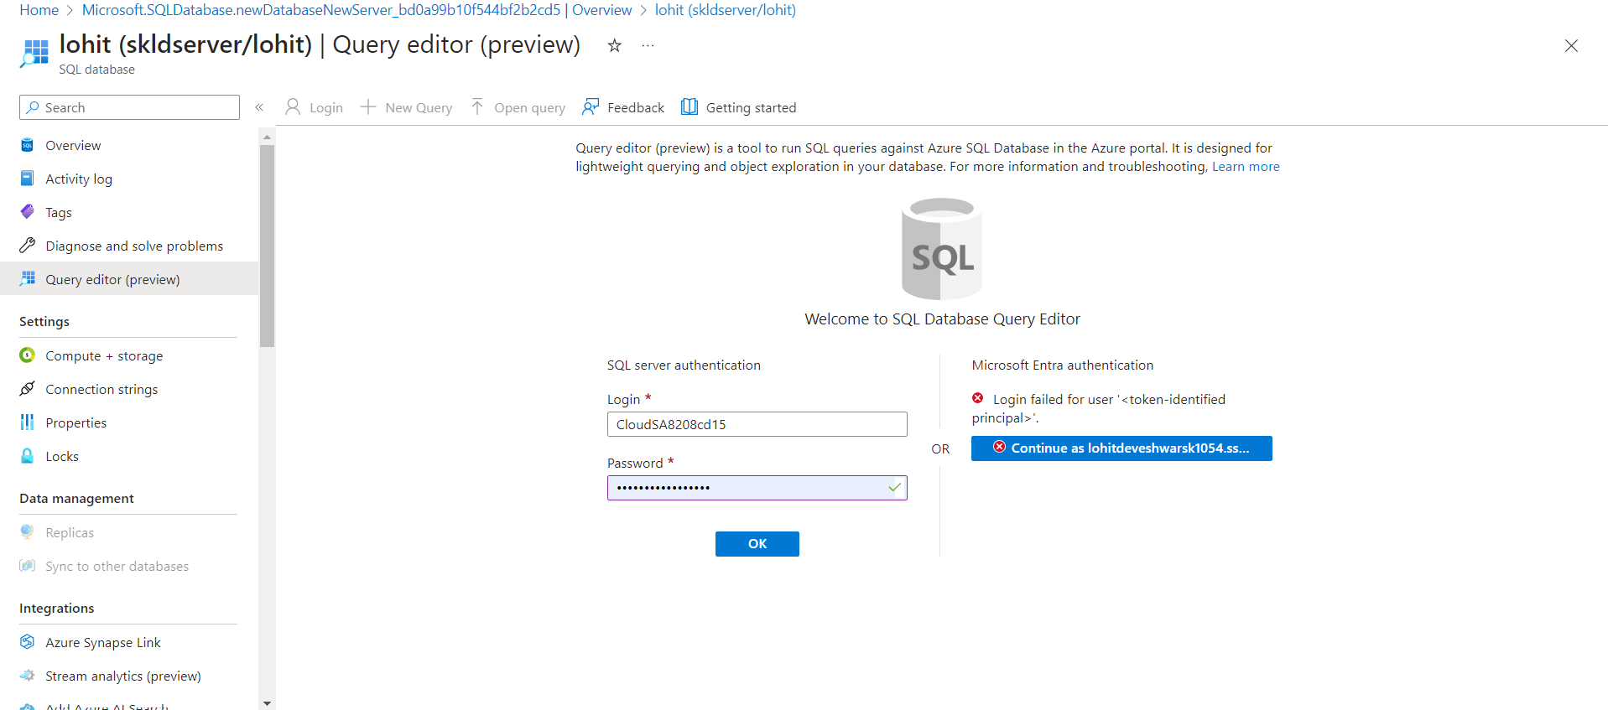

Exp 17

**CREATE A STORAGE SERVICE USING ANY PUBLIC CLOUD SERVICE PROVIDER (AZURE/GCP/AWS) AND CHECK THE PUBLIC ACCESSIBILITY OFTHE STORED FILE TO DEMONSTRATE STORAGE AS A SERVICE**

* OPEN AZURE AND GOTO STORAGE ACCOUNTS AND CREATESTOROAGE ACCOUNT
* ENTER THE RESOURC GROUPAND AND STORAGE ACCOUNT NAMEAND REVIEW AND CREATE AND CLICK TH CREATE AND YOUR STORAGE ACCOUNT WILL BE DEPLOYED SUCESSFULLY.
* OUR STORAGE ACCOUNT IS CREATED. STEP4: GOTO STATIC WEBSITE
* AND ENABLE AND ENTER YOUR INDEX AND ERROR HTML FILES NAMES.
* AND GOTO STORAGE EXPLORR(REVIEW) AND AND GOTO BLOBCONTAINERS AND WEB AND UPLOAD THE TWO HTML FILES INIT
* AND AGAIN RETURN TO STATIC WEBSITE AND OPEN THE PRIMARYLINK AND YOUR WEB PAGE IS CREATED

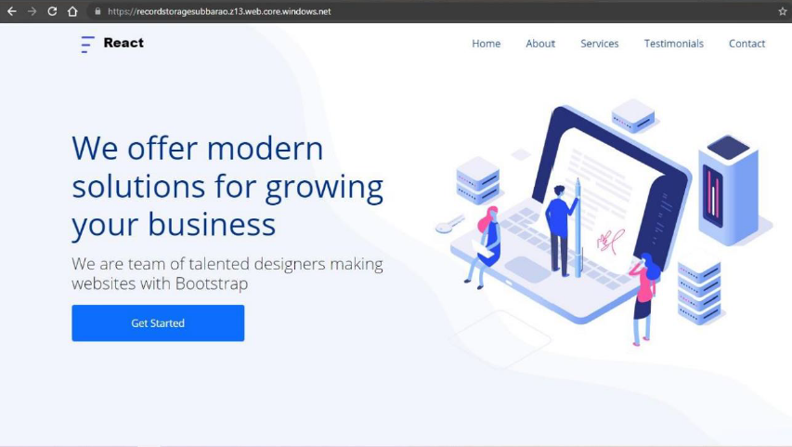

Exp18

**CREATE A SQL STORAGE SERVICE AND PERFORM A BASIC QUERY USINGANY PUBLIC CLOUD SERVICE PROVIDER (AZURE/GCP/AWS) TO DEMONSTRATE DATABASE AS A SERVICE (DAAS)**

* GOTO AZURE AND GOTO SQLDATABASE.
* Now Create a Sql Databse
* SELECT THE RESOURCE GROUPAND ENTER THE SERVERNAMETHATAPPLICABLE.
* IN NETWORKING SELECT ALLOW AZURE SERVICES AND RESOURCES TO ACCESS THIS SERVER.
* IN ADDITIONAL SETTINGS SELECT SAMPLE.
* AND THE SQL DATABASE IS DEPLOYED
* NOW GOTO QUERY EDITOR.
* NOWAGAIN LOGIN TO THE SQLDATADATABASE
* OUR TABLES WILL SHOWN AND TYPE THE QUERY TO EXCUTED

